The condition of the “If” statement below is never true (so the program never goes on the « Goto »).

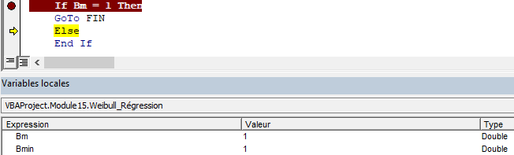

If have tried several conditions that doesn’t work neither:

Bm=Bmin

Bm=1.0

Bm=CDbl(1)

Bm<= 1

Bm<= 1.0

Bm<=CDbl(1)

**I just want the program to exit if the variable Bm = 1.**

I have tried also these conditions in a previous « Do while » loop as follow:

Do While condition1 **And Bm <> 1**

It doesn't work neither.

**What could be the solution to this issue ?**